Job Title: Street Cricket Casual Coach
Reports to: Cricket Wales Diverse Communities Officer Southeast Wales
Date: May 2022
Main Purpose of the Job
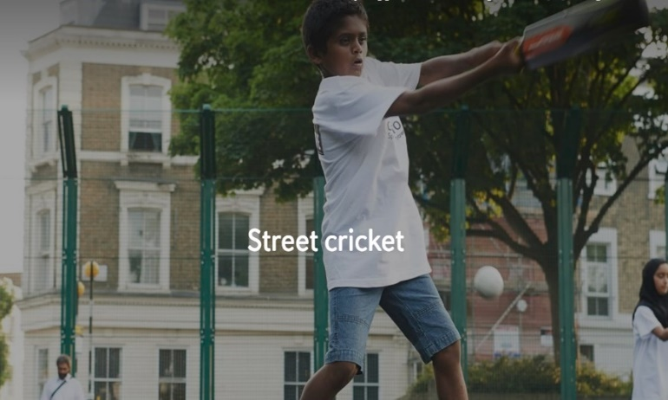
To develop and deliver the Chance to Shine Street Project to offer access to cricket in disadvantaged communities where there is a lack of accessible provision.
- engaging 16–24-year-old young people in cricket.
- To work closely with local communities to inspire regular participation and be a role model for Cricket Wales at all times.
- We require coaches to run two initial centres in central Cardiff Grangetown and Newport Pillgwenlly
Specific Tasks and Responsibilities
- To engage young people within the local community and inspire on-going participation in the Street project.
- To lead weekly cricket activity as part of a team with other activity leaders, with support from another casual coach or members of Cricket Wales staff.
- Able to produce exciting and engaging plans for weekly cricket activity which are relevant to the age and experience of participants and link to previous activity.
- To act as a role model for participants during the session and at other times when within the local community, raising the profile of Cricket Wales and Chance to Shine Street.
- To work with the Diverse Communities Cricket Development Officer or another member of Cricket Wales’ staff to identify the life skills workshops that participants would benefit from.
- To develop a rapport with key personnel from other organisations, such as venue/site staff, amongst others.
- To support the Cricket Wales, staff in completing attendance records and registration forms.
- To develop and maintain a positive image and reputation for the Cricket Wales and Chance to Shine.
- To adhere to all relevant Cricket Wales’ policies and procedures.
- Helping identify other potential activity leaders, particularly as you leave or withdraw from offering support
Experience / Skills Needed
- No formal qualification needed, but a cricket coaching qualification would be ideal
- Experience of working with young people in a sporting or other setting
- Candidates will be expected to have (or obtain) a DBS check from the ECB if they haven’t already got one.
- Welsh language desirable but not essential.
Pay: the role will paid on a claim basis at the rate of £15 per hour (inclusive of holidays) plus expenses for approximately 10 hours a week over the summer period (June-August).
To apply contact Mark.White@cricketwales.org.uk by 2nd June 2022

