**Briton Ferry Steel ladies**

Briton Ferry Steel ladies team officially began at the start of 2018 in readiness for the season 2018.

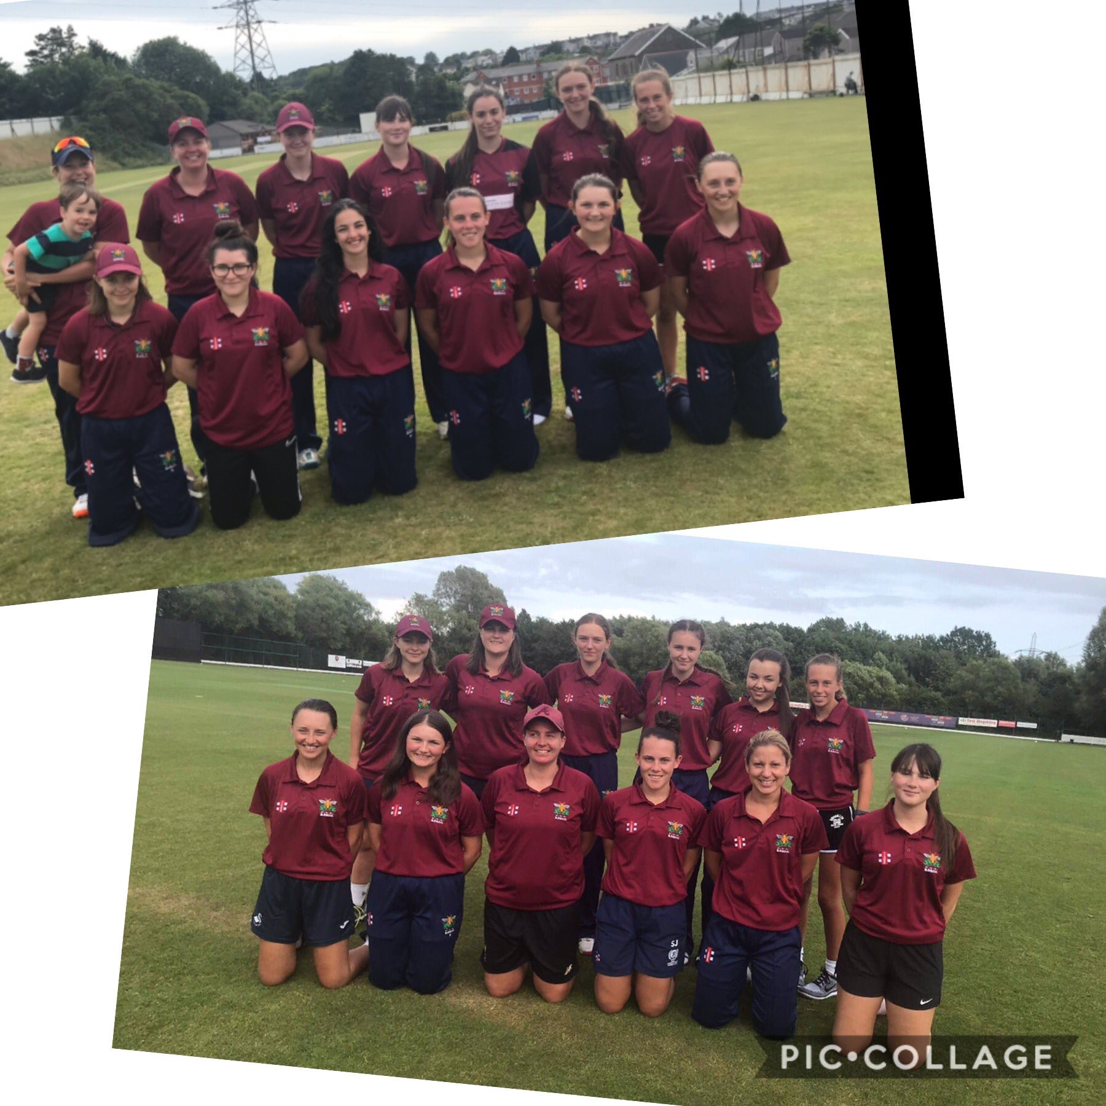

The senior ladies team play in the South and West Women’s Regional League. They also play in the Vitality t20 knockout cup. Our younger girls team play in the Ladies Taverners under 13 and under 15 Cup and we also have girls in the younger age groups who have played girls friendly matches and festivals and were ready to play in a new Girls League in 2020.

During season 2019 there were 4 teams in the SWWRL, however season 2020 was due to have 6 teams in the league—which reflects the growth in Ladies cricket. Each team in the league has a range of players who play in the senior county team or at county age groups. We have a young team at Briton Ferry with Claire Nicholas and Rachel Priest sharing their experiences with the younger girls.

The team spirit and friendships built amongst the players in out ladies teams, and with the supporters, makes our team special and we are looking forward to building on the good start we have had over the seasons to come.