Welsh Cricket Clubs Defibrillator Initiative

We would be delighted to support each Welsh Cricket club and help each club get this lifesaving piece of equipment, we have already helped a lot already throughout the years. We could give each club grants, advice, CPR/Defibrillator training session and ongoing support and maintenance of the device.

As a charity we are able to help each club with a £300 grant towards the cost of the equipment.

We would advise each club to have a dual functioning defibrillator (which means it can be applied to an adult or child with just a flick of the switch). The defibrillator carries out internal daily diagnostics and sends an SMS message to the Charity each day at about 2:00 am. The charity will then notify the user if necessary.

AED Cost

The cost is £695 for the iPAD SP1 from the charity after the grant has been provided. The normal cost is £1000 - £1100 for the defibrillator. We can help the club achieve further funding and help with their fundraising if they decide to go down this route. https://cymruhearts.org/PageContent/Calon%20Defibs%20IPAD%20Information%20Pack.pdf
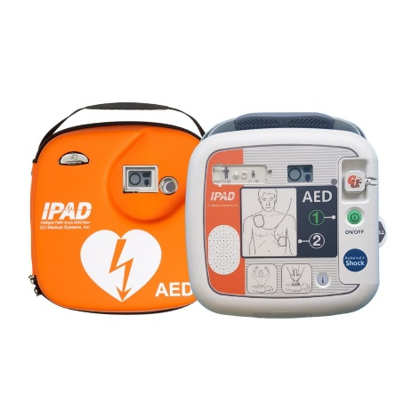

The cost of an unlocked/locked heated cabinet (needs electrical supply) for a public access AED is £395.
https://cymruhearts.org/PageContent/Defibrillator%20storage.pdf

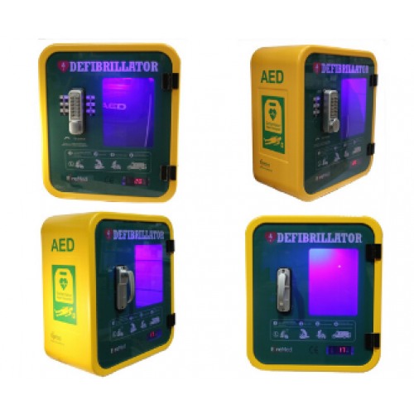
Replacement costs – pads need to be changed when used or every 2 years. Cost around £30-£35. Battery needs to be replaced every 4.5 years at a cost of £160.

Defibrillator Training

Every defibrillator we place at a cricket club we will provide a free CPR/defibrillator training session for the club, this takes no more than 45mins-1hr.
While anyone could use a defibrillator with the easy voice prompts, CPR and defibrillation training and awareness make a significant difference as to whether or not people feel confident to take action should a situation arise where CPR or defibrillation are needed. (It is estimated that only 40% of bystanders who witness a cardiac arrest, perform CPR).

Location

The AED can either be mounted in a box outside as a Public Access Defibrillator or inside on a bracket or an internal cabinet. Clearly it should be positioned where it can easily and quickly accessed but it needs to be protected from frost. (The pads are damaged below 0 C.) I appreciate that most clubs don’t own their own premises so a portable defibrillator they have in their first aid bags would be more appropriate. It should be noted to clubs who use school facilities and sport clubs to make sure the defibrillator they have access to is available 24/7 and not locked away in the school building which is shut when the cricket session is taking place. We will advise each club who purchase that they need to register the device on the Circuit (the National Defibrillator Registry).

